Computer Networks Lab 2
Muhammad Hassan Khalid
21L-5692

Question 1

ls command
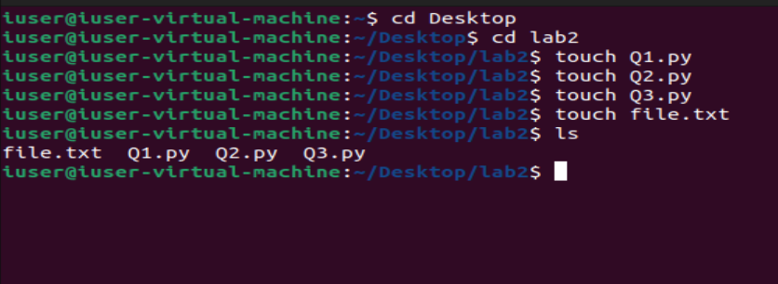

The ls command list all the files and folders in the specific directory you are using the ls command on.

cd command
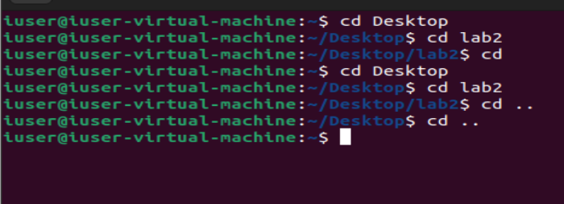
The cd command allows you to go to a folder or location the syntax is cd desired location, to go back to the main home just write cd and if you want to go to one folder back write cd ..

pwd command
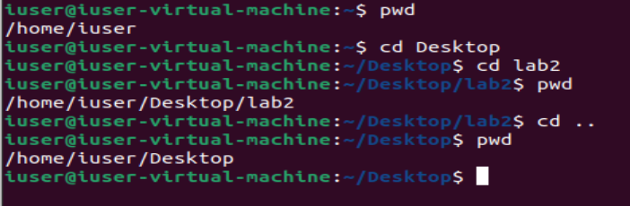
It prints the current location or directory you are in at the current moment.

mkdir command
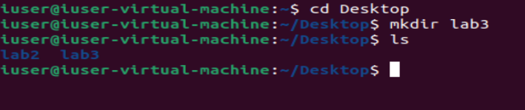
It creates a folder in the desired directory you are in.

rmdir and rm command
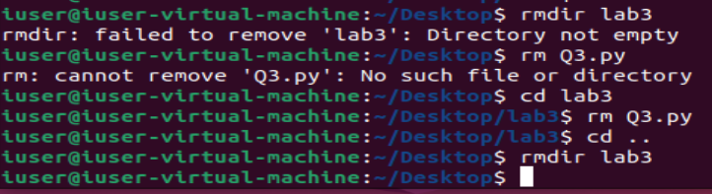
The rm commands removes a file whereas the rmdir command removes a directory only and only if it is empty.

cp command
It copies a file to your desired location address.

mv command
It moves a file to your desired location address.

touch command
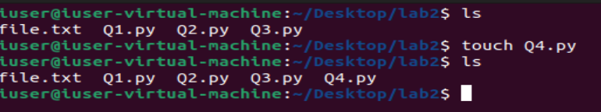
It creates a new empty file in the directory.

Question 3
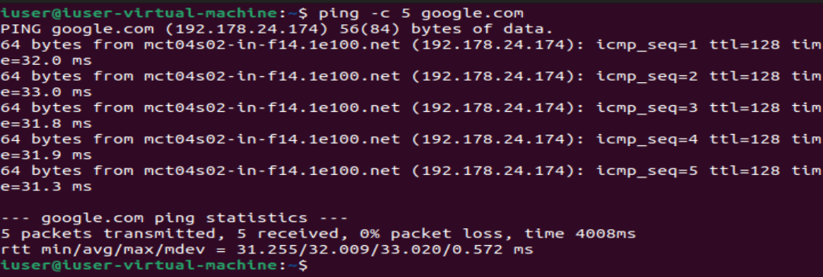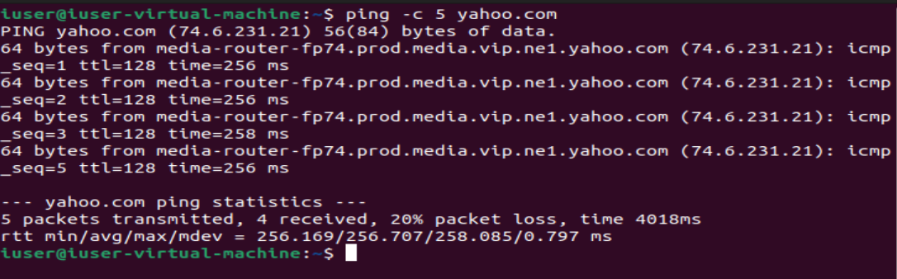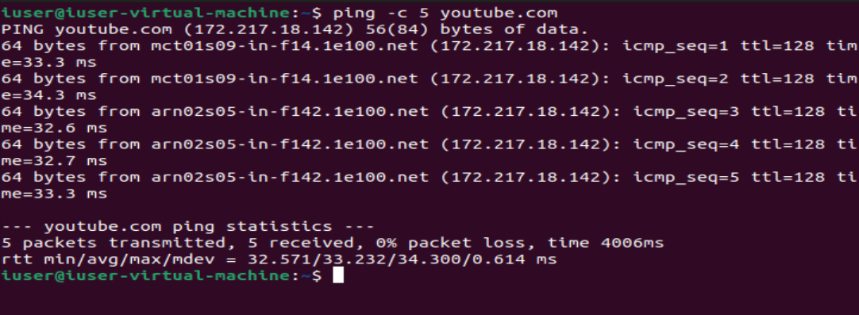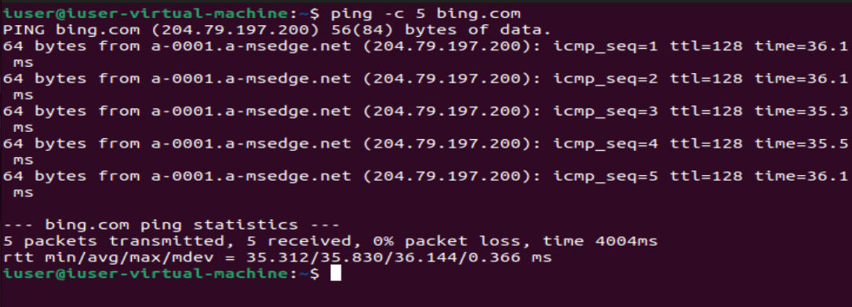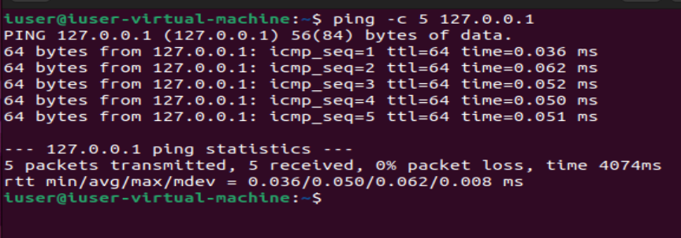

The lowest latency or ping time is of our own machine which is understandable as we are pinging to our own machine so now distance is being covered. On the second most comes google.com followed by youtube.com and then bing.com. The highest ping was of yahoo.com and 1 packet was lost which could be a server-side issue and the highest ping of 257.

Question 4
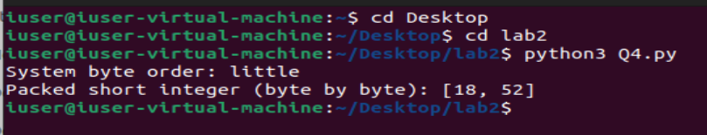

Question 5
